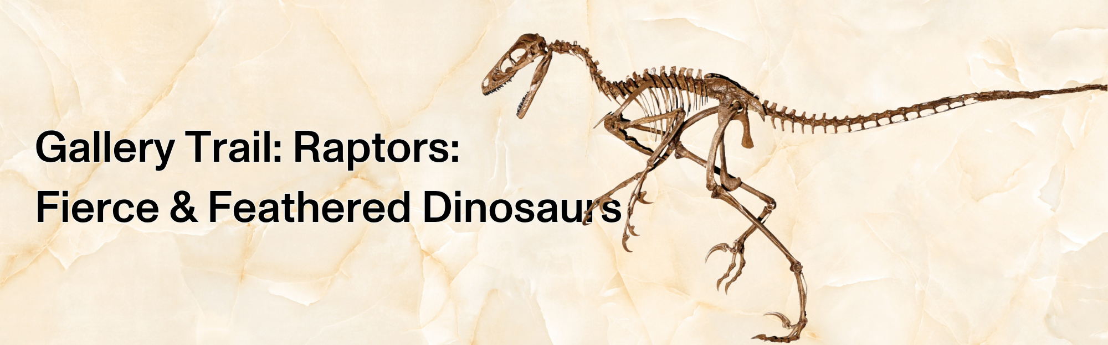
Before Birds, There Were Raptors

Raptor dinosaurs have captured our imagination for a long time, made famous in movies and as basketball mascots, but there’s so much more to these incredible dinosaurs. As the group of dinosaurs most closely related to modern-day birds, their bones provide clues that link dinosaurs and living birds. Discover the stories they tell in this new exhibition, and use this gallery trail to help you record what you learn.

- Use any objects you like to help you answer the questions on this gallery trail.
- You can work in small groups on the questions and the activities.
- Remember that you’re sharing the space with other people. Be respectful.
- Choose a working space that doesn’t block someone’s view or stop them from moving past.

Please use pencils and not pens to keep the objects safe.

Before you start

✎ Write down 5 things you know about raptor dinosaurs (Think about how they look, what they eat, how they live, etc).

1.

2.

3.

4.


5.

What are Raptors?
Raptor dinosaurs range in body size and shape, but there are three body features they have in common that no other dinosaurs have. Here’s a hint: look at their toes and tails.
For each key feature that defines a raptor, sketch an example in the box, and explain what you learned about it in the first section of the exhibition.
Feature (toe-related):

Explanation:

Feature (tail-related):

Explanation:

Dig Deeper:
While raptors are not defined by their body coverings (some non-raptors have the same body covering), they are all covered by the same thing. What is it?
Body covering:

Explanation:

Raptor Biology and Behaviour
✎ As you go through the second part of the exhibition, you’ll learn more about the lives of raptor dinosaurs.

Explain what you learned for each category of raptor biology and behaviour

Category | What I learned…
Hunting & Feeding
Nests & Growth
Locomotion & Flight

Amazing Adaptations
✎ Adaptations are something an animal has on its body or ways that an animal behaves that help it survive better in its natural habitat.

Choose one raptor dinosaur and one living bird that you learned about in the exhibition.
On the next page:
- Sketch the dinosaur and bird
- Label the adaptations that help each one survive
- Explain the features that show how raptors and living birds are related

Dinosaur Modern bird

Now I know….
✎ Look back at the 5 things you wrote about raptor dinosaurs on page 1. Did anything change?

Explain how the exhibition changed what you thought you knew about raptors and other dinosaurs, or confirmed what you already knew.

What is your favourite thing that you learned?

Back in Class:
✎ Using everything you learned, write a story about an event in the life of a raptor dinosaur.
Share your stories with us @ROMtoronto

