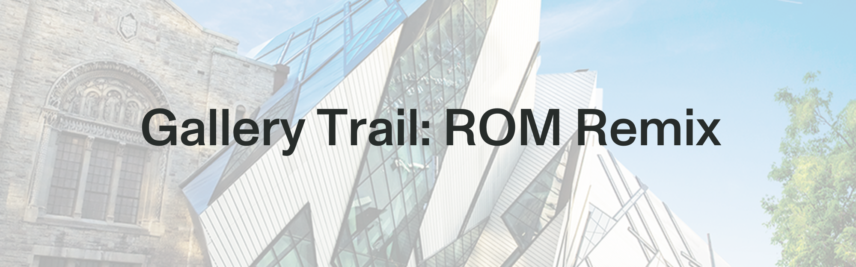

**Explore** a gallery. **Read** the labels. **Observe** the objects & displays. **Listen** to sounds & people. **Learn.**

**Museum Guidelines:**

* Walk. Don’t run.
* **Only** touch things with a “please touch” sign.
* Work alone or in groups.
* Choose the questions you want to answer most
* Respect other people in the gallery
* Use pencils in the gallery.

✏️ What is this gallery about? How do you know?

✏️ Choose 3 objects. Explain why you think each one belongs in this gallery.

|  |  |
| --- | --- |
| Object | Why is it here? |
|  |  |
|  |  |
|  |  |

✏️ **Draw** your favourite thing in the gallery. Add **labels or notes** showing important points. **Explain** why it’s your favourite.

✏️ **ROM Remix:** Choose three things that are **NOT** already displayed together, but you think have something in common that would make a great new display.

The three objects are:

Now write a museum label for your new display. It should tell visitors:

* What is the theme of your display?
* Why did you put these three objects together?
* What story are they telling?

**Back in Class:** Use 2D or 3D art tools to re-create these objects in your new display. Combine all your class displays to make a remixed museum!