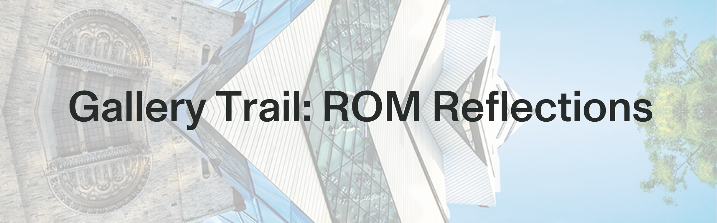

**Explore** a gallery. **Read** the labels. **Observe** the objects & displays. **Listen** to sounds & people. **Learn. Engage. Reflect.**

# Museum Guidelines:

* Walk. Don’t run.
* **Only** touch things with a “please touch” sign.
* Work alone or in groups.
* Choose the questions you want to answer most
* Respect other people in the gallery
* Use pencils in the gallery.

## Before you explore:

✏️ Whose voices or perspectives do you **expect** to learn from at the museum? Why?

## 

## In the gallery:

✏️ What is this gallery about?

✏️ If there was no sign with the gallery’s name, would you still think that this is what the gallery is about, or would you think it was something different? Explain how or why you would think this.

✏️ How does it compare to what you **expected** before you explored?

✏️ Choose **2** objects you want to learn more about. Make sure they are objects with labels.

* Whose **perspective** is reflected in the label?
* If it’s a **cultural object**, how well do you think the label reflects the perspectives of **the object’s original creators or users,** or people **whose lives were affected by it**?
* If it’s a **natural object**, how well do you think the label represents the **diversity of perspectives** of the people who find this living thing, rock, mineral, or metal significant?

|  |  |  |
| --- | --- | --- |
| Object | Whose perspective is reflected and how do you know? | How well do you think it reflects original diverse perspectives? Why? |
|  |  |  |
|  |  |  |

✏️ **ROM Remix:** You are now a curator in charge of putting together a new exhibition for ROM.

* What is your exhibition’s name and what is the theme or topic?
* What 5 objects would be part of your exhibition? (Use [collections.rom.on.ca](http://collections.rom.on.ca) for more ideas.)
* Explain whose voices or perspectives will be part of your exhibition, and how you will make sure they’re represented respectfully.
* In one paragraph, sum up your exhibition for the Visitor’s Newsletter. Your paragraph should convince the intended audience for your exhibition that they want to see this one.

**In-Class Extension:** Use 2D or 3D art tools to create your exhibition. Combine all your class exhibitions to make a remixed, reflective museum.